**Experiment 4: To understand Continuous Integration, install and configure Jenkins with Maven/Ant/Gradle to set up a build job.**

**Aim:**

To understand the concept of Continuous Integration (CI) and implement it by installing and configuring Jenkins with Maven, Ant, or Gradle to automate the build process. This study aims to explore how Jenkins helps in setting up a CI pipeline, executing automated builds, and improving software development efficiency.

**Theory:**

# Introduction to Continuous Integration (CI)

Continuous Integration (CI) is a software development practice where developers frequently integrate their code changes into a shared repository. Each integration is verified using automated builds and tests, ensuring that issues are detected early. CI helps streamline the development process, reduces manual errors, and improves software quality.

**Key Principles of CI:**

1. **Frequent Code Integration** – Developers merge changes multiple times a day.
2. **Automated Build Process** – Code is compiled, built, and tested automatically.
3. **Immediate Feedback** – Issues are detected early and fixed promptly.
4. **Consistent Environment** – CI ensures that software builds are reproducible across different environments.

To implement Continuous Integration, organizations use CI tools like Jenkins, which automates the build, test, and deployment process.

# Jenkins: A CI/CD Automation Tool

Jenkins is an open-source automation server that enables developers to automate software builds, tests, and deployments. It supports integration with version control systems (Git, SVN) and build tools like Maven, Ant, and Gradle.

**Key Features of Jenkins:**

* **Automated Builds** – Supports scheduled or triggered builds based on repository changes.
* **Build Pipelines** – Allows chaining multiple jobs for end-to-end automation.
* **Plugin Support** – Offers 1,500+ plugins for integration with tools like Docker, Kubernetes, and Slack.
* **Scalability** – Can distribute builds across multiple nodes for faster execution.

# Build Tools: Maven, Ant, and Gradle

Build tools are essential in CI to compile source code, resolve dependencies, and generate deployable artifacts.

## 1. Apache Maven

* A widely used Java-based build automation tool.
* Uses POM.xml (Project Object Model) to define project dependencies, build lifecycle, and plugins.
* Supports phases like clean, compile, test, package, install, and deploy.

**Command to build a project:**

mvn clean install

●

## 2. Apache Ant

* Older than Maven, but still used for Java builds.
* Uses an XML-based build script (build.xml) to define tasks.
* More flexible but requires explicit configurations.

**Command to execute a build:**

ant build

●

## 3. Gradle

* Newer build tool, used for Java, Kotlin, and Android development.
* Uses a Groovy or Kotlin-based build script instead of XML.
* Faster than Maven due to its incremental build mechanism.

**Command to build a project:**  gradle build

●

# Jenkins Integration with Maven, Ant, and Gradle

Jenkins can be configured to automate builds using these tools. The integration process involves:

1. **Installing Jenkins** and setting up build tools.
2. **Creating a job in Jenkins** that fetches source code from Git.
3. **Configuring build steps** to invoke Maven, Ant, or Gradle commands.
4. **Executing automated builds** and monitoring results.

# Advantages of Using Jenkins for CI

* **Faster Development Cycle** – Automated builds and testing reduce manual effort.
* **Early Bug Detection** – Continuous integration ensures quick issue identification.
* **Improved Collaboration** – Developers work on the latest stable codebase.
* **Efficient Deployment** – Jenkins supports integration with Docker, Kubernetes, and cloud platforms.

**Implementation:**

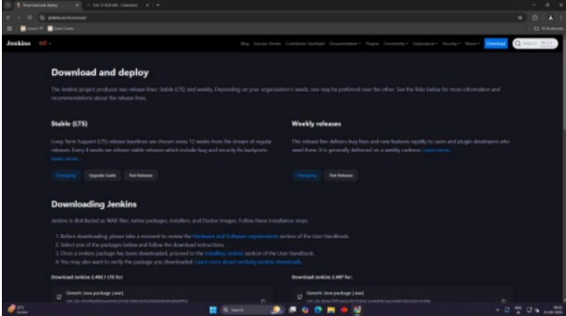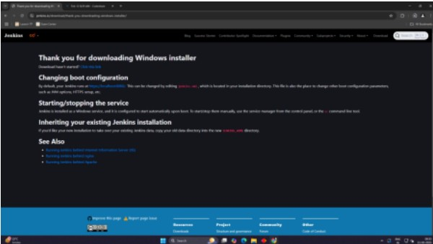

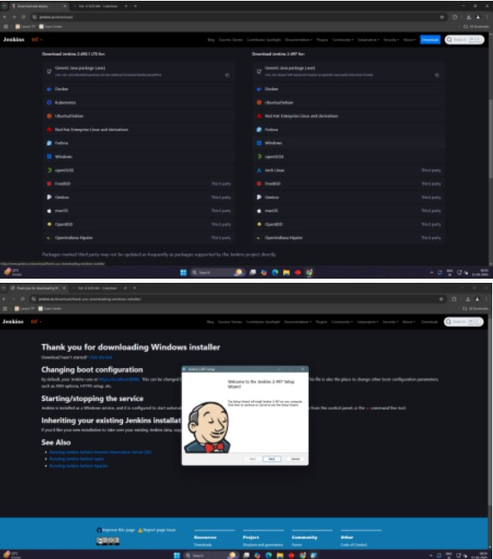

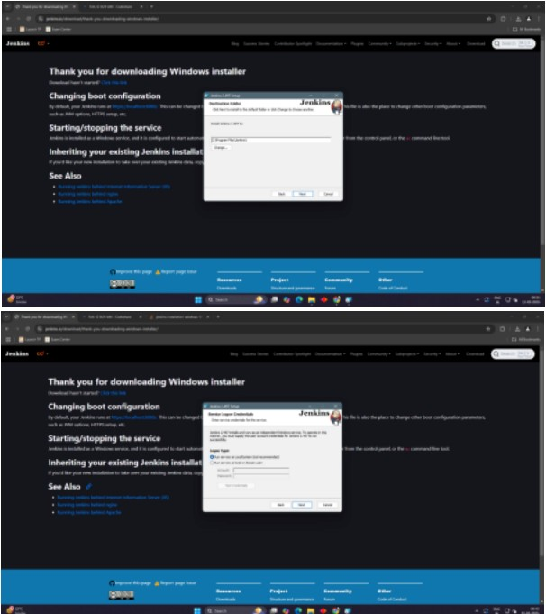

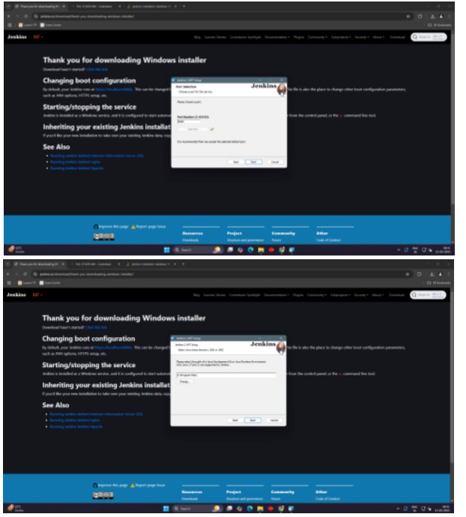

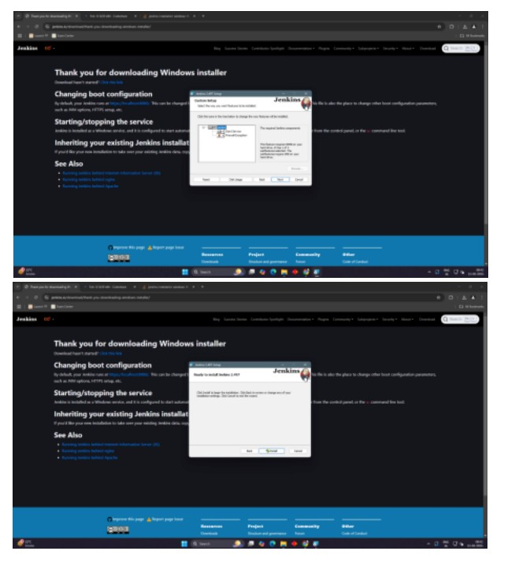

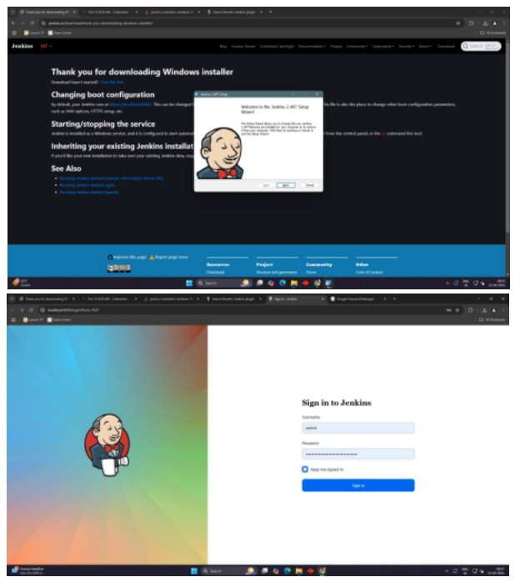

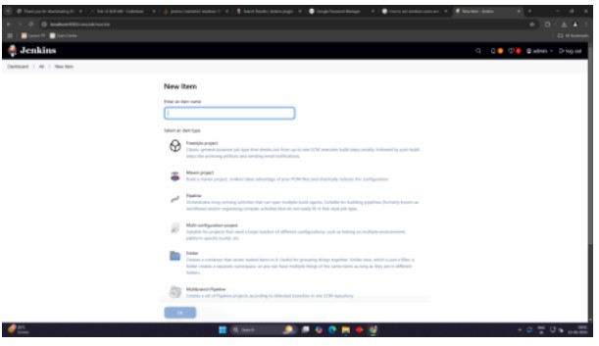

**Conclusion:**

Thus, we have successfully installed and configured Jenkins.